External Partner Use
View from the Frontlines: April 8, 2020

Executive Summary
- Operational challenges. Many systems are furloughing (still receive benefits and will be called back once volume increases) their staff including nurses.
- Providers and patients seem to be adjusting to telehealth. Issues lie primarily in the over 80-age range that like flip phones.
- Telehealth is a way to engage the patient with their families that are even in different locations.

Opportunities
- GO2 to fill a gap in providing Virtual Tumor Board resources
- Expanding telehealth and the possibility to move SDM to that model, (can it be demonstrated that it is as effective for patients and cost effective?)
- More focus on the benefits of Palliative Care as more patients are encouraged to stay home. How to “safely delay patients”
- Opportunity and need for resources/messaging/awareness campaign (social media?) that COEs can use to re-engage their screening patients and help re-establish a regular screening schedule once the program hiatus ends post-COVID-19.

Detailed Background Insights Below
National Context (Federal Policy, National Partner Positions)
The Association of State and Territorial Health Officials (ASTHO) website provides an interactive map, updated daily, for tracking state public health policies in response to COVID-19. Here is a screen capture of the state health agencies that have enacted Elective Medical Procedure restrictions (note: does not include policies enacted by local authorities):

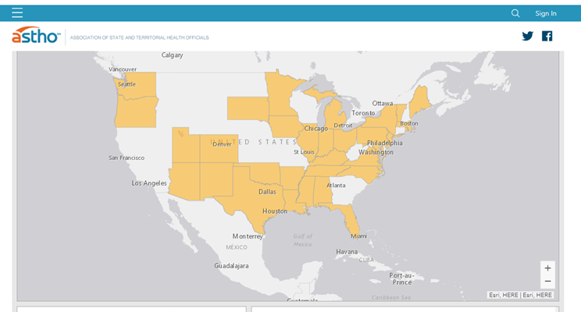

Additional ASTHO COVID-19 resources and documents, including issue briefs, legislative alerts, and blogs can be found here.

State-Level Context (State Policy)
Here is a good example of a Minnesota Public Health resource to assist with implementation of their Elective Medical Procedure Executive Order: a FAQ document that includes the Elective Surgery Acuity Scale.

SCOE
Note: The below information primarily addresses staffing/employment impacts of the current pandemic on our health facility partners. News accounts tend to use the terms “layoff” and “furlough” interchangeably, but they have distinct meanings and we have tried below to be consistent with what is being publicly reported.
SHRM notes, “A furlough is considered to be an alternative to layoff.” It is a temporary reduction in hours or a period of unpaid leave. The furloughed employee remains on the payroll but is unpaid. In contrast, “a layoff is a temporary separation from payroll [i.e., separation from employment].” In the latter case, the employer expects to recall the employee when work is again available. Occasionally a reduction in force, which is intended to be permanent, is called a layoff when in reality there are no plans to recall the impacted employees.

We have heard few instances of SCOE staff being specifically impacted, but the below information notes the system/facility-level impacts that have been reported through news accounts and personal communications.
- Furloughing 2,500 staff (primarily non-clinical) across 8 hospitals. Seven facilities are SCOEs. The health system announced, “the goal is for the furloughs to be temporary.” I have reached out to our SCOE point of contact, to check on her and the program.
- Furloughing staff; number affected hasn’t been announced. Meanwhile, nine hospital employees have tested positive for COVID-19. Their program director, shares that her hours have been reduced, though she has an opportunity to become part of ICU labor pool. They are “bracing for the worst.” She also mentions that their Incidental Pulmonary Nodule program is keeping her busy in the interim while the screening program is on hiatus. I have asked her to share any insights she sees on the impact of COVID-19 management/chest imaging on their IPN program.
- Furloughing 131 staff, 20 of which are only “partially furloughed”/hours significantly reduced. These furloughs have been voluntary, which has prevented layoffs so far. Anticipated to last for 4 weeks. Our contact notes that even though screenings are on hold, their patient volume is up 15%! “Patients are very understanding about rescheduling. We’ll be running when this is over! I have been able to catchup on QA, policies, quarterly reports, etc.” She also notes that the community has been very supportive of their hospital—sending food, etc. to staff--and that the hospital hasn’t yet experiencing a PPE shortage, though they are being conservative with using their PPE.
- One healthcare system is implementing a “temporary furlough program” for primarily non-clinical staff. Have reached out to contact who is the Director of Imaging Services, to check on them.
- Have reached out to others part of the above system.
- Furloughing an undisclosed number of staff, primarily non-clinical.
- 6 SCOES in their system, all medical imaging facilities. They are furloughing undisclosed number of staff and asking even clinical staff to reduce hours voluntarily. Affected staff will retain their benefits.
- Furloughing undisclosed number of non-clinical staff. Affected staff will retain partial benefits.
- Large system has had 734 employees (2.1% of workforce) test positive for COVID-19 across their health system. How many were infected through workplace contact versus community-spread is unknown. They have a universal mask policy in place for employees and visitors. Note: One facility in their system is a SCOE, and we have been in communication with them this year about adding additional facilities.

CCCOE
- Point of care testing and PPE seem to be the biggest needs. Not sure about other equipment such as ventilators. But we are doing ok, all considered. Just preparing for the peak. Our NN team is working from home. Our thoracic surgery clinic numbers are way down. We are still doing diagnostic EBUS, etc. No blood testing in place of tissue as far as I know.
- Right now, our lung volumes have been stable and although I am able to do some work from home, I have been coming in most days. Bronchoscopies are only being performed if deemed necessary and unable to obtain dx otherwise because of the risk. Our hospital has not encountered a surge yet...they are expecting things to ramp up at any time. At this point, I do not believe our interventional pulmonologist is working in the ICU yet. We are holding multidisciplinary clinic and conference via webex.
- Everyone is safe. Patient are nervous and some do cancel…blood, chemo, etc. My concern are the screeners that have to be deferred until May or June, we are not currently doing any OP Imaging here. I just keep moving forward and try to schedule those that are due in late May. I also worry about those that may possibly lose their jobs and subsequently are left either un-insured or underinsured and won’t be able to complete the annual screening. This of course is a nationwide problem. Well COVID will run its course and there will be many challenging times ahead.
- Our director has forced us to use vacation time because there is not enough work. I still have about the same number of patients, but they do not see it that way.
- Our scans are currently on hold and we're hoping to be back up and running by Mid-May. Once we are up and running, our diagnostic scans will definitely be put on the schedule before screening CT's. We have actually kept any screening follow up scans on the schedule as we don't want to delay any workup for possible cancer. Our incidental volume has definitely increased as we have more people coming in with pulmonary complaints and getting chest scans. So we're still conducting our nodule review board on Monday mornings and only reviewing incidentals. A good majority of them are inpatient with rule out COVID. Our surgeons are triaging their patients and only operating on those that are urgent cases.
Other Hospitals
- Mountain Health Network (WV)—furloughing 550, and cutting hours of an additional 450.
- Franklin Memorial Hospital & Lakes Regional General Hospital/LRG Healthcare (NH)—furloughing 600 for “up to 4 months.” Furloughed employees will retain their medical insurance and will be eligible for unemployment.
- Maury Regional Health (TN)—furloughing 340 employees.
- Williamson Medical Center (TN)—furloughing 200 employees. Furloughs “are expected to be temporary.”
- North Bend Medical Center (OR)—furloughed 130 employees. They will retain their medical insurance.
- Jackson Health System (FL)—undisclosed number of furloughs announced for non-clinical staff—implemented as a reduction in working days/two days unpaid leave per week. Clinical staff are not affected and are being re-deployed to COVID-19 response.
- Premier Health (OH)—undisclosed number of furloughs of non-clinical staff.
- Kettering Health Network (OH)—undisclosed number of furloughs.
- Mount Carmel Health System (OH)—“fewer than 500” employees being furloughed.
- Conway Medical Center (SC)—furloughing 100 staff. “Frontline care providers” not included.
- Multi-state Steward Health Care System (AZ, AR, FL, LA, MA, OH, PA, TX, UT) implementing furloughs across their system. Two Steward facilities in FL and MA are in the SCOE network.
- Mountain Health Network (WV)—550 employees furloughed and an additional 450 working reduced hours.
- Wellforce Health System (MA)—719 staff furloughed for 90 days; an additional 1,236 having hours and earnings reduced.
- We are still doing some biopsies and surgeries. RT and infusions are still happening as well as clinical trials. Our tumor board is now all virtual. Navigators are working virtually as well.
- Hospital is not doing well. They are talking about layoffs; in fact, they have already cut hours in some areas. We have not been doing well financially, I am afraid this is going to put us over the edge! I don't know what will happen to our patients. We have such a large indigent population, that no one wants. We are still doing radiation, but those numbers have also dwindled. We have not had Case Review or Tumor Boards for about 1 month. We have an agency that does tumor registry; we have suspended work with them and with our Clinical trials piece. We don't have an infusion clinic but most of the private practices have had to also pair down.

Other Media/Resources
ONS-https://www.ons.org/coronavirus?ref=HC&ref=HP
ASCO-https://www.asco.org/asco-coronavirus-information
NCCN-https://www.nccn.org/covid-19/default.aspx
COA-https://communityoncology.org/coronavirus-covid-19-practice-resources-and-protocols/

